# Experiment 1.1

**Student Name:** Avinash Kumar **UID:** 21BCS8908

**Branch:** B.E.CSE **Section/Group:** CC_648-B

**Semester:** 6th **Date of Performance:** 17/01/2024

**Subject Name:** MAD-Lab **Subject Code:**21CSH-355

1. **Aim:** Installation and configuration of Android Studio.
2. **Objective:** The objective of installing and configuring Android Studio is to set up a development environment for creating Android applications. The process involves installing the necessary tools and components, configuring the development environment, and preparing the IDE for efficient Android app development.
3. **Input/Apparatus Used:**Computer, Internet connection, Android studio installer, mouse, keyboard, storage etc.

# Script and Output:

**Step1**-System Requirements: Java JDK5 or later version, Java Run time Environment (JRE) 6 Android Studio

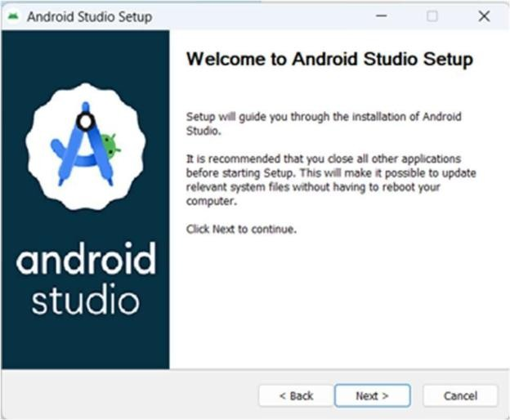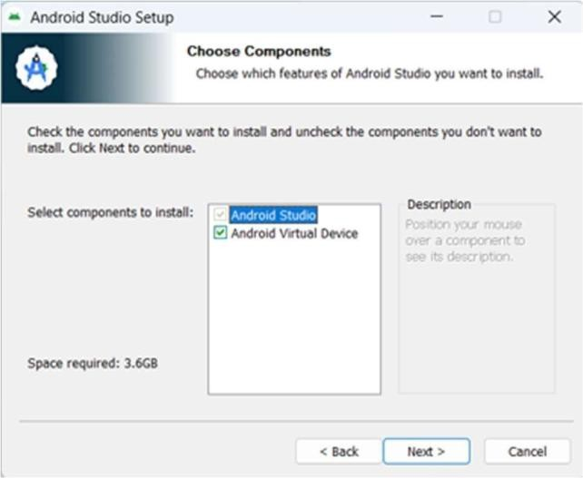

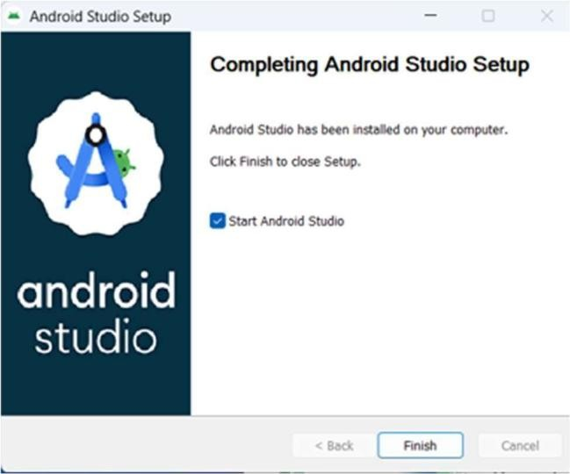

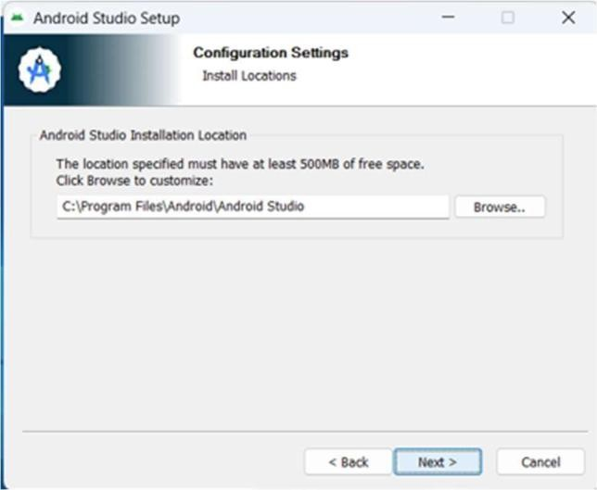**Step2**-Setup Android Studio:

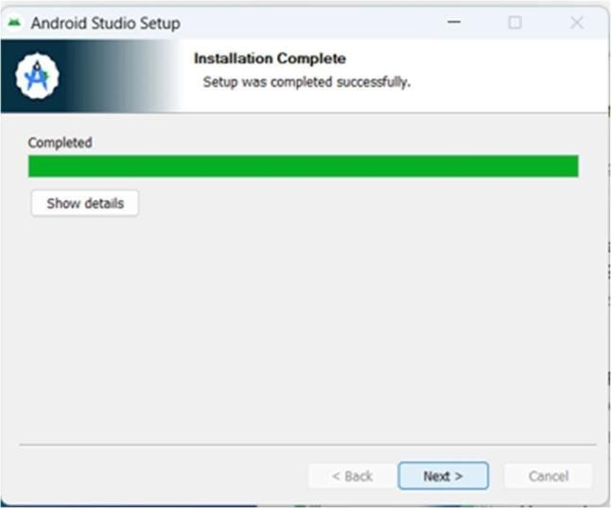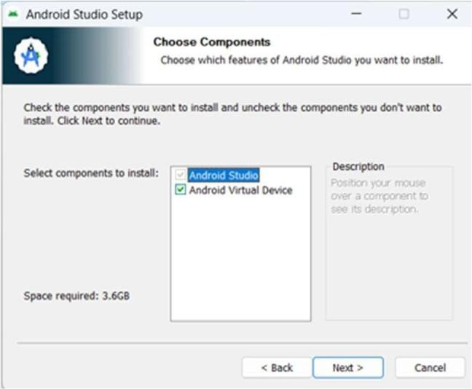

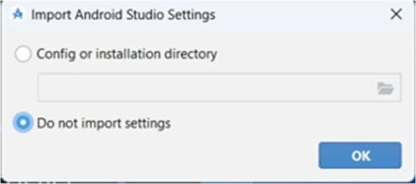

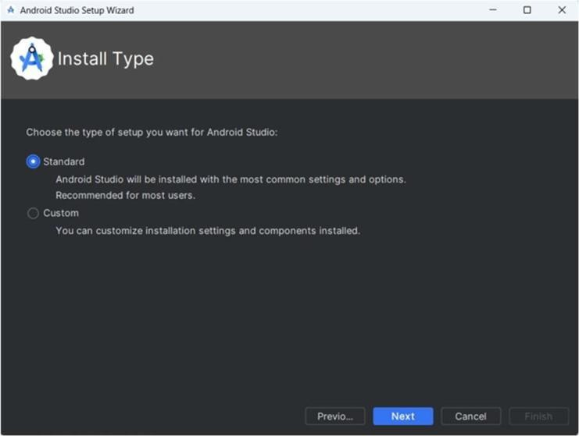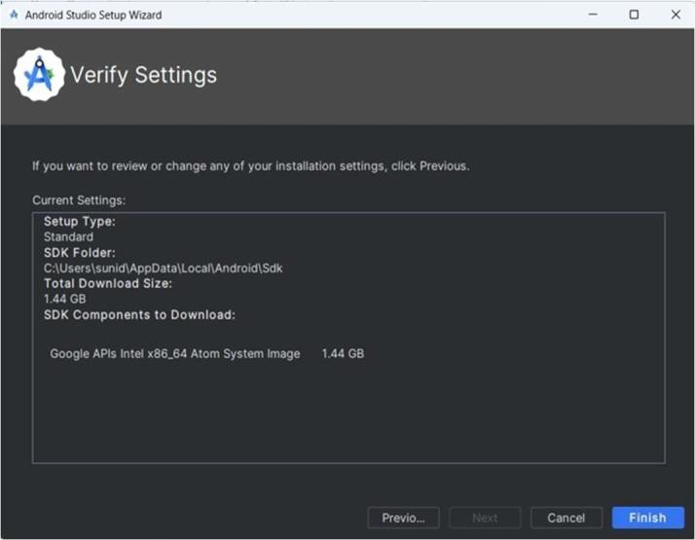

* 1. You can start your application development by calling start a new android studio project in a new installation frame should ask Application name, package information and location of the project.
  2. After entered application name, it going to be called select the form factors your application runs on, here need to specify Minimum SDK, in our tutorial, I have declared as API23: Android 6.0(Mashmallow)

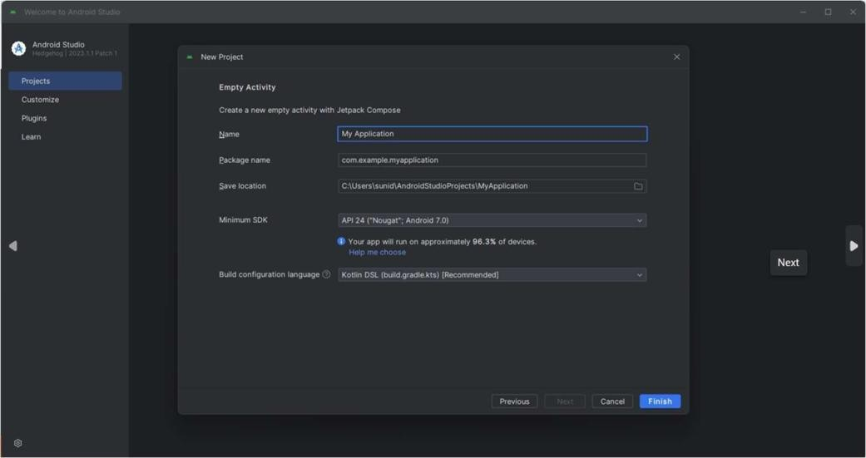

* 1. The next level of installation should contain selecting the activity to mobile,it specifies the default layout for Applications.
  2. At the final stage it going to be open development tool to write the application code.

**Step3-** Create Android Virtual Device

